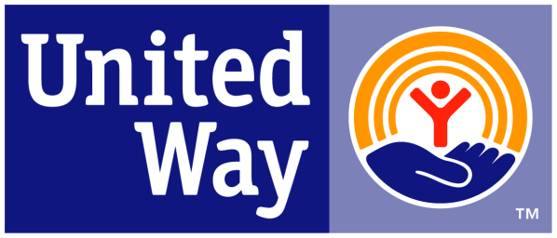
United Way of Pennsylvania

PA 2-1-1 Talking Points
General Information
- Across the country, 2-1-1 is used for health and human services information and referral, and disaster relief.
- PA 2-1-1 is currently funded by a combination of United Way support, grants and private contributions, contracts and some county government support.
- 2-1-1 has many benefits to the State and people of the Commonwealth, including:
  - Connecting people in need to health and human service assistance available through government programs and private non-profit organizations in their communities
  - Providing assistance to communities in a time of disaster, which allows 9-1-1 calls to be primarily for the need of first responders
  - Connecting volunteers and donors with organizations who can leverage resources to meet the needs of the community
- Currently there are 6 regional 2-1-1 programs operating throughout the state and covering approx. 85% of the state’s population
- PA 2-1-1 usage increases by 15% each year

Data Collection
- Each center operates using the same database of community resources and caller activity, allowing for statewide easy-to-find information that is categorized with consistent taxonomy across the state.
- Numerous reports and information can be collected from the data system individualized to specific criteria, such as a specific zip code or call taken.
- Data collected by 2-1-1 can be useful for a multitude of state and local government entities.
- Data collected can be used to inform city and county planning processes.
State Benefits
- The 2-1-1 system will be a stable, statewide communication infrastructure that can be used in a broad variety of ways to support the work of state and local government
- The 2-1-1 system has the potential to be the portal that government can use to quickly get information out to the public efficiently.
- The 2-1-1 system has the potential to reduce duplicative services.
- A strong 2-1-1 system would allow for a partnership with the State and municipalities in managing emergencies.
- 2-1-1 will provide information on the needs and gaps in services that can help policy makers and funders make decisions on those services.
- Will ease the burden on state departments by helping reduce the number of misdirected calls

Cost Savings
- 2-1-1 is a tool to connect individuals with resources in their community which may help them avoid the need for more costly levels of care.
- There will be a reduction in non-emergency 911 calls and the number of 1-800 numbers funded by government.
- 2-1-1 will allow for a cost avoidance for state and local government of misdirected calls for services.
- An upfront investment from the state can help the 2-1-1 system become available to 100% of Pennsylvania citizens, improve consistency of service across the state and increase the effectiveness of referrals for people in need.
- 2-1-1 is a tool to quickly mobilize and process volunteers and/or donations in times of emergency or crisis.
- Time will be saved for individuals/families through a one-stop call center to locate a variety of services.
- A 1999 study by the Public Policy Center at the University of Nebraska, concluded a statewide 2-1-1 system could generate cost savings between $7.6 and $16.5 million annually from such factors as increased efficiency in getting information to consumers, reducing overlapping information and referral costs and improved community planning through use of call data.

PA 2-1-1 Needs/Asks
- State funding needs to be secured to stabilize PA 2-1-1 as the most efficient and effective system possible for all Pennsylvania citizens.
  - We are asking for an initial general fund appropriation from the State of $1.5 million. Ongoing funding will grow with the needs of the network and be shared.
    - Once statewide operation is achieved, financing of the PA 2-1-1 system will be shared- state general fund, United Way/local, and individual service contracts.
    - Currently United Ways and other local contributors are raising about $3 million annually to fund PA 2-1-1.
- PA 2-1-1 needs to extend coverage to the entire northwest portion of the state, which is 15% of the state’s population.
  - The cost to bring this coverage to the northwest has been projected at $300,000 in each of the first three years
  - A local yearly commitment of $100,000 has been made by several United Ways and a United Fund, but start-up funding must be found.
- In addition to finalizing coverage, PA 2-1-1 will:
  - Establish MOUs to coordinate 2-1-1 services with the myriad of state initiatives that occur
  - Hire a statewide executive to coordinate operations and coordinate 2-1-1 regions’ progress to achieve consistent quality assurance standards
  - Integrate the database system for mobile use and accessibility to private entities that have services to provide
  - Establish long-term sustainability, including statewide fundraising from the private sector and contracting with state government to become the front door for health and human services at the state level

